**CSC 4110**

**GROUP PROJECT II**

**Group Members:** Issa Habeeb, Ali Algahim, Emran Ali, George Ebaugh, Munassar Shariff, Nadia Aktar, Rasheed Kareem

Our project is about creating an exciting arcade game called 'Space Invader.' In the game, you control a spaceship, move it left and right, and shoot at alien invaders. The game gradually becomes harder as more enemies show up. There's a 'Start' button to begin, and your score, displayed at the top left, increases by ten every time you hit an invader. Your spaceship's health is shown at the top right and decreases by ten if an enemy hit you or passes you. The goal is to achieve a high score while staying alive and defending your spaceship from the invaders.

**Why should YOUR TEAM be chosen?**

**Expertise in Tkinter**: Our team has extensive experience and expertise in using Tkinter to create graphical interfaces. We have successfully completed project II, which involves Tkinter, which demonstrates our deep understanding of the library's capabilities and its potential for creating user-friendly interfaces.

**Expertise in HTML and CSS**: Our team boasts extensive expertise in HTML and CSS, having successfully completed some projects (previous classes) that showcase our proficiency in web development. We are well-versed in writing clean, semantic HTML and crafting responsive, visually appealing CSS styles.

**Diverse Skill Set**: Our team comprises individuals with diverse skills, including graphic design, user experience (UX) design, and programming (CSS, HTML etc).. This diversity allows us to approach the project holistically, ensuring that the interface not only functions flawlessly but also look visually appealing and user-friendly.

**Innovative Design**: We have a record of accomplishment of producing innovative and eye-catching designs that captivate users. Our creative approach to web design incorporates the latest.

**Responsive Web Design**: We priorities creating responsive web designs that adapt seamlessly to various screen sizes and devices. Our commitment to a mobile-first approach guarantees that our project will reach a diverse audience.

**Scalability and Adaptability**: We design interfaces with scalability in mind, allowing for easy expansion and adaptation as project requirements evolve. Our interfaces are robust and capable of handling future enhancements and changes.

**Collaborative Teamwork**: Our team has a strong collaborative spirit. We communicate effectively, share ideas, and work seamlessly together to deliver a cohesive and integrated interface that aligns with the project's goals.

**Passion for UI/UX**: Creating graphical interfaces using Tkinter is not just a project for us; it is our passion. We are genuinely excited about the opportunity to work on this project and are committed to delivering outstanding results.

**Challenges:**

**Integration of Turtle and Tkinter:** Integrating Turtle graphics with a Tkinter GUI can be a bit challenging, as they have different event handling systems. Careful design and communication between the two components are required.

**PyInstaller and Packaging:** Creating a standalone ".exe" file using PyInstaller can be challenging. You'll need to ensure that all dependencies are correctly packaged, and the application works on different platforms.

**Documentation and Comments:** Maintaining consistent and comprehensive documentation, including docstrings and comments, can be time-consuming, but it's crucial for code readability and maintainability.

**Code Quality and Avoiding Code Decay:** Ensuring that your code is well-structured, maintainable, and doesn't suffer from "code decay" (gradual deterioration of code quality over time) is essential. Regular code reviews and adherence to best practices are key to mitigating this challenge.

**Essential difficulties:**

**Game Physics and Movement:** Implementing realistic movement and physics for the player's spaceship and the invading aliens can be challenging. You need to calculate velocities, collisions, and handle smooth animations for objects moving in space.

**Collision Detection**: Accurate collision detection is crucial in a Space Invaders game. You must ensure that bullets hit their targets, the player's ship can be damaged or destroyed, and the aliens can be eliminated.

**Enemy Behavior**: Designing the behavior of the alien invaders is a non-trivial task. You need to create patterns and strategies for the aliens to follow, such as descending toward the player, firing at regular intervals, and changing direction.

**Game Difficulty Scaling**: Balancing the game's difficulty level as players progress is important. You'll need to adjust the speed, number, and behavior of the aliens to keep the game challenging but not impossible.

**Graphics and Animation**: Creating visually appealing graphics and smooth animations for the game can be time-consuming. You might need to design and animate sprites for spaceships, bullets, and aliens.

**Testing and Bug Fixing**: Thorough testing is essential to identify and fix bugs, glitches, and issues in the game. This can be time-consuming as you need to playtest different scenarios and edge cases.

**AWS hosting quote:**

**Linux/Unix:**

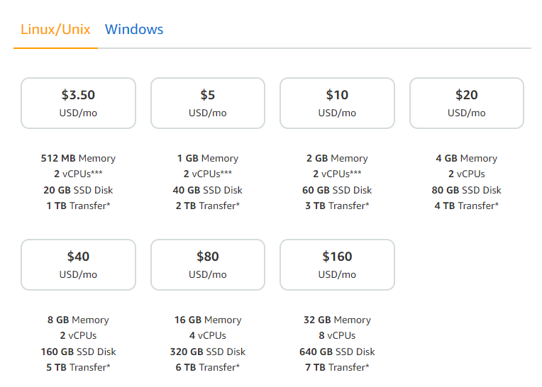

**Windows:**

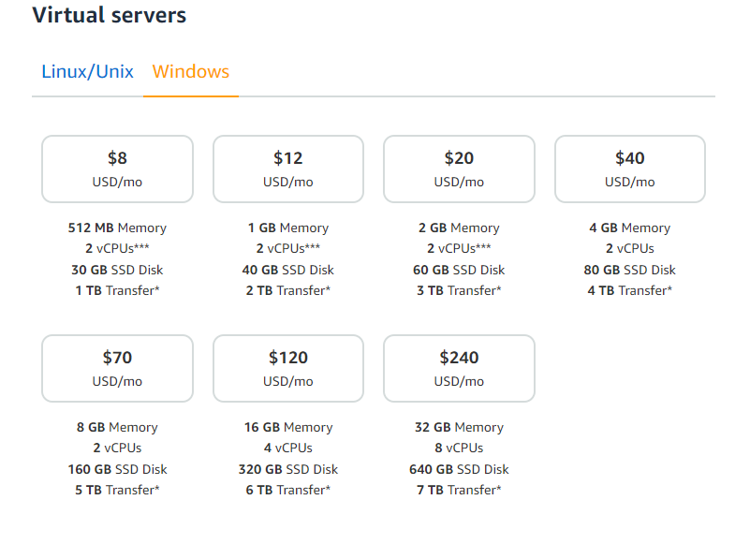

**Future Recommendations:**

Our arcade game, 'Space Invader,' delivers a fun gaming experience with its straightforward and enjoyable gameplay. To further enhance it, we are considering adding user profiles for score tracking and achievements. Implement online leaderboards for global competition, awards and achievements for added challenges, and a multiplayer mode for interactive play. Create power-ups, allow ship customization, and invest in high-quality visuals and sound.

**APA references:**

**Amazon Web Services. (n.d.). Amazon LightSail Pricing. Retrieved from** [**https://aws.amazon.com/lightsail/pricing/**](https://aws.amazon.com/lightsail/pricing/)